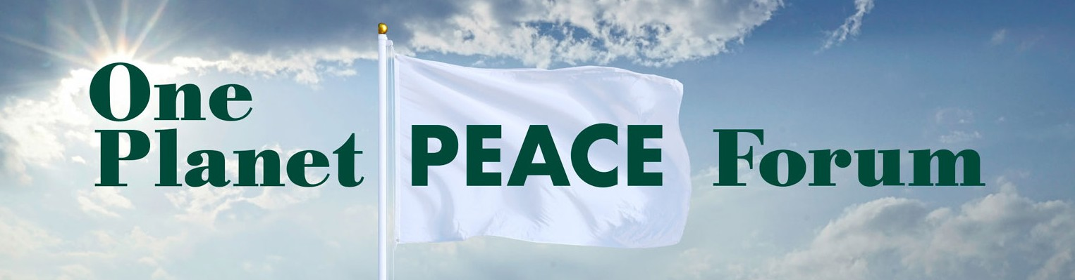

Building the Future We Envision:
A Virtual Interfaith, Interdisciplinary Gathering

One Planet Peace Forum (OPPF) is pleased to announce the virtual launch of its annual gather- ing for building a culture of peace. We invite everyone from across the region, nation, and world to attend this year’s online program, September 25-27, to be introduced to many of the same outstanding speakers who will also be presenting at the in-person gathering next September, 2021, on the shores of the Piscataqua River in Eliot, Maine.

Register Now!
Friday, 9/25/20
to Sunday, 9/27/20

Sponsored by the Abbey of Hope, an interfaith Cooperation Circle of United Religions Initiative (URI), and funded by generous grants from URI and the Maine Humanities Council, One Planet Peace Forum was created as an annual event to offer a universal platform for people of all spiritual and secular expressions to co-create solutions to the most challenging issues facing humanity today.

The program, from 3-5:30pm ET Friday, 9/25, Saturday, 9/26, and
Sunday, 9/27, will integrate short keynote talks, panels with discussion, contemplative practice, and sacred performance to create a safe place for collaboration by applying universal principles, values, and tools, such as truth telling and unitive justice, to find common ground through interfaith and interdisciplinary dialogue and action.

Presenters for 2020 include: Audrey Kitagawa, Parliament of the World’s Religions; Rev. Vic- tor Kazanjian, United Religions Initiative; Kurt Johnson, author, The Coming Interspiritual Age;

Layli Miller Muro, Tahirih Justice Center; Swami Tyagananda, Vedanta Society of Boston; Phil- ip Hellmich, The Shift Network; Dot Maver, National Peace Academy; Phil Goldberg, author, American Veda; Mohammad Al Samawi, author, The Fox Hunt: A Refugee’s Memoir; William Smith, National Center for Race Amity; Ben Bowler, UNITY EARTH; David Ragland, Truth Telling Project; Melinda Salazar, Seacoast Peace Academy; Robert Shetterly, painter and found- er of Americans Who Tell the Truth; and, Kristin Hoffmann, Bella Gaia. (Several presenters are pictured below)

Presenters

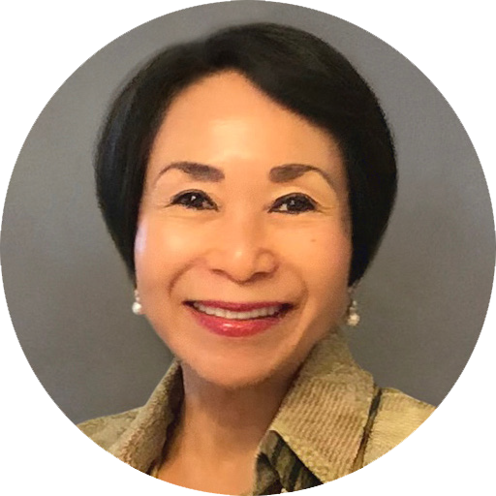
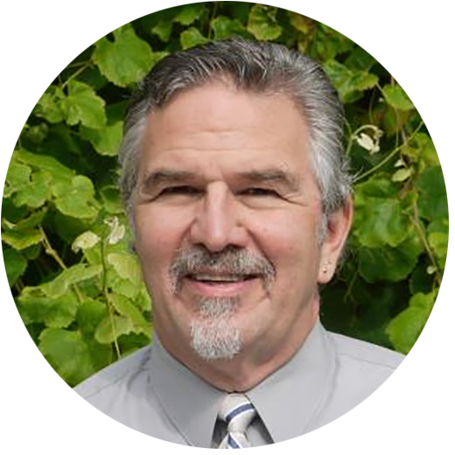
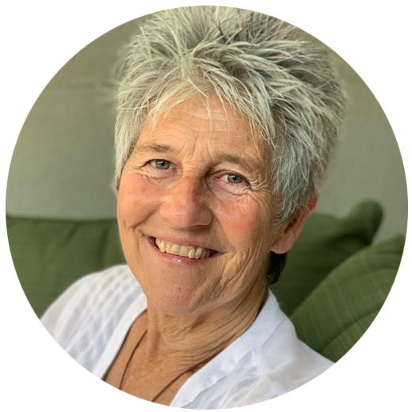
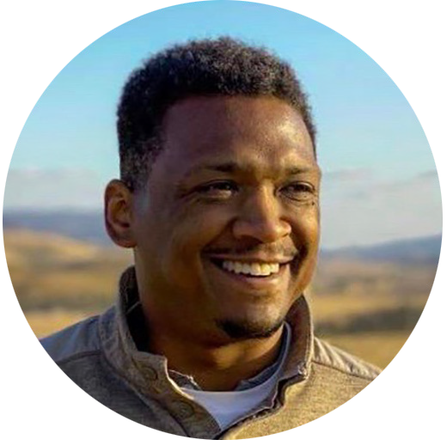

Audrey Kitagawa
Rev. Victor Kazanjian Dot Maver
Dave Ragland

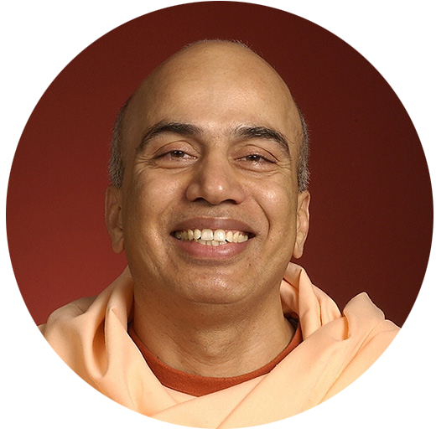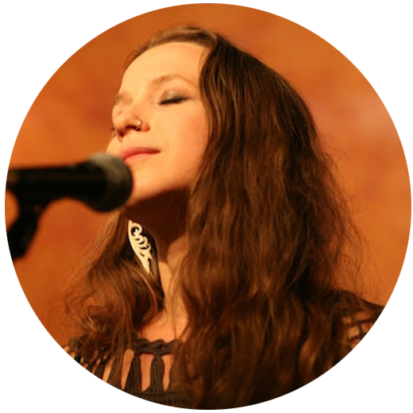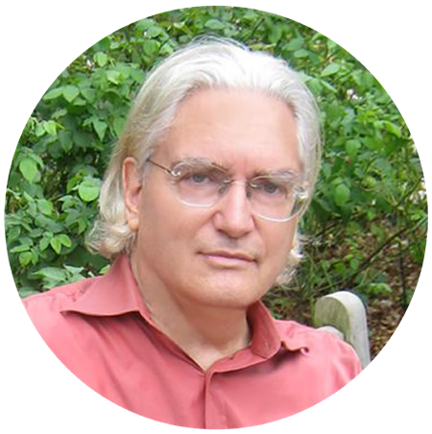

Swami Tyagananda
KristinHoffmann
Phillip Hellmich
Kurt Johnson

Everyone is invited to join with all of our partners – The Good of the Whole; UNITY EARTH; We, the World; The Source of Synergy Foundation; The Shift Network; National Peace Acad- emy; Chaplaincy Institute of Maine; Friends Forever International; Seacoast Peace Academy;

Greater Concord Interfaith Council; Ramakrishna Vedanta Society; and, the National Center for Race Amity - to help make this online gathering a lasting contribution to global harmony.
Sponsors:
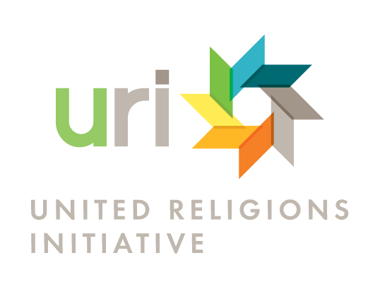
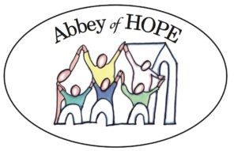
Partners

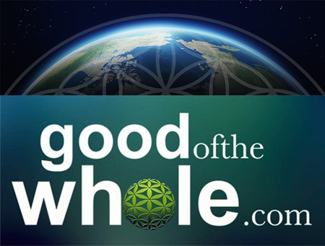
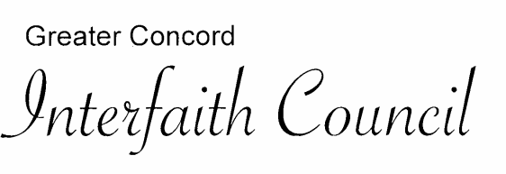

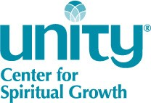
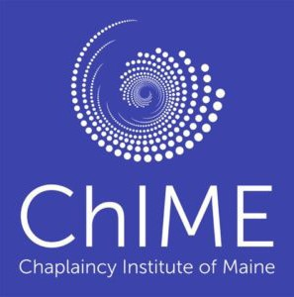

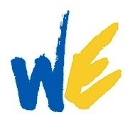
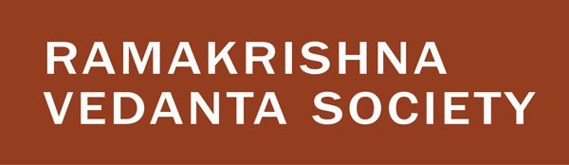

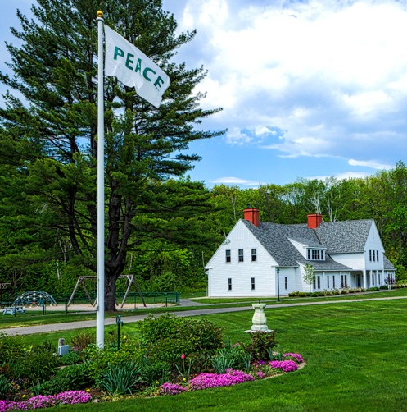
One Planet Peace Forum emerged out of the commitment of the Abbey of Hope to bring people of diverse traditions together to promote interfaith understanding through shared experience leading to action steps that cultivate harmony, justice, unity and peace across traditions. OPPF shares the perspective of the Parliament of the World’s Religions, as stated in their Declaration, A Global Ethic, “We consider humankind our family… We commit ourselves to a culture of non-violence, justice, and peace… to make a just and peaceful world, we much first change the consciousness of individuals…” To this end, the theme of this year’s virtual gathering is “Build- ing the Future We Envision.”

We invite you to register for the September 25-27 virtual forum by visiting: http://oneplanetpeaceforum.org/register

Please visit us at our Facebook page, too.

The planned 2021 One Planet Peace Forum on-the-Piscataqua will be held at Green Acre Retreat and Conference Center, Eliot, ME.

